AWS Cloud Documentation
Part-1
From On-Premises Infrastructure to Cloud Computing Using AWS

1. Introduction to Cloud Computing
In today’s digital world, almost every application and service we use depends on cloud computing. Applications such as Netflix, Instagram, Amazon, Google Drive, Zoom, and Spotify all rely heavily on cloud infrastructure to deliver services to millions of users across the world.
Before understanding Amazon Web Services (AWS), it is extremely important to first understand:
- how traditional infrastructure worked,
- the problems organizations faced,
- why cloud computing became necessary,
- and how AWS revolutionized the IT industry.
This documentation is designed for beginners who are starting their journey into cloud computing and AWS from scratch.

2. Traditional On-Premises Infrastructure
Before cloud computing existed, companies used a model known as:
On-Premises Infrastructure
In this model, organizations purchased and maintained their own physical servers and networking equipment inside their own buildings or data centers.
A company running a website or application needed:
- Physical servers
- Storage devices
- Networking equipment
- Internet connectivity
- Cooling systems
- Power backup systems
- Security systems
- Dedicated IT teams
These servers were usually kept inside specially designed buildings called:
Data Centers
A data center is a facility that contains large numbers of physical servers and networking equipment used to run applications and store data.

Example Scenario — E-Commerce Company
Consider a company launching an online shopping website.
To make the website accessible to users, the company would need:
- servers to host the website,
- databases to store customer information,
- storage systems for images and files,
- networking equipment for internet access.
The company had to purchase and maintain all of this infrastructure manually.

3. Challenges Faced in On-Premises Environments
Although on-premises infrastructure worked for many years, organizations faced several major problems.

3.1 High Infrastructure Cost
Setting up a data center required huge investment.
Organizations needed to spend money on:
- servers,
- racks,
- networking devices,
- cooling systems,
- electricity,
- backup generators,
- security,
- maintenance teams.
For startups and small businesses, this was extremely expensive.

3.2 Difficulty in Scaling
Suppose a company normally receives:
- 1,000 users daily.
During a festive sale or marketing campaign:
- traffic may increase to 1,00,000 users.
The existing servers may not be able to handle this sudden increase in traffic.
To solve this problem, companies had to buy additional servers.
However:
- purchasing servers takes time,
- installation takes time,
- configuration takes time.
As a result, businesses could not scale quickly.

3.3 Resource Wastage
Many companies purchased extra servers for future growth.
However, during normal periods:
- most servers remained unused.
This resulted in:
- underutilized infrastructure,
- wasted electricity,
- unnecessary operational costs.

3.4 Maintenance Complexity
Physical infrastructure requires constant maintenance.
Organizations needed teams to:
- monitor servers,
- replace failed hardware,
- update operating systems,
- secure networks,
- handle backups,
- manage cooling and power systems.
This increased operational complexity significantly.

3.5 Risk of Downtime
If a physical server failed:
- applications could stop working,
- websites could become unavailable,
- business operations could be interrupted.
This could lead to:
- financial loss,
- customer dissatisfaction,
- reputational damage.

4. Why Organizations Moved to Cloud Computing
To overcome the limitations of traditional infrastructure, cloud computing was introduced.
Large technology companies such as:
- Amazon Web Services (AWS)
- Microsoft Azure
- Google Cloud Platform
built massive global infrastructures and started offering computing resources as services over the internet.
Instead of buying physical servers, organizations could now:
- rent computing resources,
- use them on demand,
- and pay only for what they use.
This completely transformed the IT industry.

5. What is Cloud Computing?
Definition
Cloud computing is the delivery of computing services such as:
- servers,
- storage,
- databases,
- networking,
- software,
- analytics,
- security,
- and applications
over the internet on a pay-as-you-go basis.
In simple terms:
Instead of owning physical infrastructure, organizations rent resources from cloud providers whenever needed.

Important Clarification
Cloud computing does NOT mean servers no longer exist physically.
Cloud providers still use physical servers inside massive data centers.
The difference is:
- organizations no longer manage the infrastructure themselves,
- the cloud provider manages it.

6. Real-World Analogy of Cloud Computing
A simple analogy to understand cloud computing is electricity supply.

Traditional Model
Imagine every house had to generate its own electricity using generators.
Each house would need:
- fuel,
- maintenance,
- technicians,
- repairs.
This would be expensive and difficult.

Modern Electricity Model
Today, electricity is provided on demand by electricity boards.
Users:
- consume electricity when needed,
- pay only for usage,
- and do not worry about infrastructure maintenance.
Cloud computing works in a similar way.
Organizations use computing resources whenever needed without owning physical infrastructure.

7. Key Characteristics of Cloud Computing

7.1 On-Demand Self-Service
Users can create resources whenever needed without human interaction.
Example:
- launching a virtual server in minutes.

7.2 Scalability
Resources can increase or decrease based on demand.
Example:
- increasing servers during high traffic periods.

7.3 Pay-As-You-Go Pricing
Organizations pay only for the resources they use.
This reduces unnecessary infrastructure costs.

7.4 High Availability
Cloud providers ensure services remain accessible even during failures.

7.5 Global Accessibility
Applications can be deployed closer to users worldwide using global cloud infrastructure.

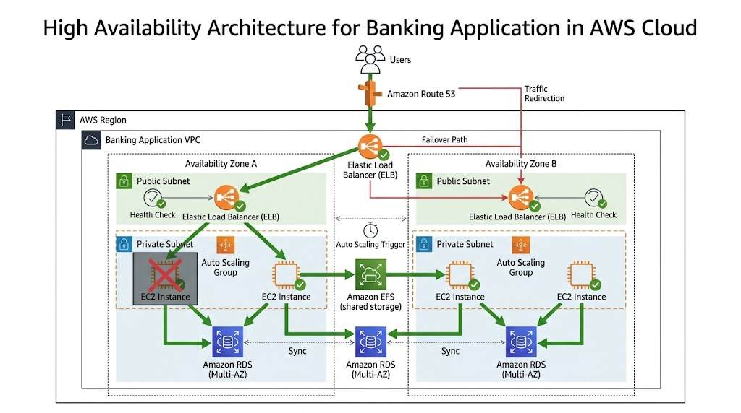

8. Types of Cloud Computing

8.1 Public Cloud
Infrastructure is owned and managed by cloud providers.
Examples:
- AWS
- Azure
- Google Cloud
This is the most commonly used cloud model.

8.2 Private Cloud
Infrastructure is dedicated to a single organization.
Used by:
- banks,
- government organizations,
- highly secure enterprises.
Provides more control but is expensive.

8.3 Hybrid Cloud
Combination of:
- public cloud,
- private cloud.
Organizations keep sensitive applications in private environments while using public cloud for scalability.

9. Cloud Service Models

9.1 IaaS — Infrastructure as a Service
The cloud provider offers:
- virtual servers,
- storage,
- networking.
Users manage:
- operating systems,
- applications,
- software.
Example:
- Amazon EC2

9.2 PaaS — Platform as a Service
The provider manages:
- infrastructure,
- operating systems,
- runtime environments.
Users focus only on deploying applications.
Example:
- AWS Elastic Beanstalk

9.3 SaaS — Software as a Service
Complete software applications delivered over the internet.
Examples:
- Gmail
- Zoom
- Microsoft 365
Users simply use the software without managing infrastructure.

10. Introduction to AWS
AWS (Amazon Web Services)
AWS is the world’s leading cloud computing platform provided by Amazon.
Amazon originally built large-scale infrastructure for its own e-commerce platform.
Later, Amazon started offering this infrastructure as cloud services to businesses worldwide.
Today AWS provides hundreds of cloud services including:
- compute,
- storage,
- networking,
- databases,
- analytics,
- AI/ML,
- security,
- DevOps tools.

11. How AWS Infrastructure Works
AWS infrastructure is designed to provide:
- scalability,
- reliability,
- fault tolerance,
- and high availability.
Understanding AWS infrastructure is extremely important because almost every AWS service depends on these concepts.
The major infrastructure components are:
- Regions
- Availability Zones
- Edge Locations
- Global Infrastructure

12. AWS Regions
What is an AWS Region?
An AWS Region is a geographical area where AWS has multiple data centers.
Examples:
- Mumbai Region
- Singapore Region
- Frankfurt Region
- North Virginia Region
Each AWS Region is completely isolated from other regions.

Why Regions Exist
Regions help organizations:
- deploy applications closer to users,
- reduce latency,
- comply with legal regulations,
- improve performance.

Example Scenario
Suppose most users of an application are located in India.
Deploying infrastructure in:
- AWS Mumbai Region
will provide lower latency compared to deploying in the United States.

Important Point
Each AWS Region contains multiple Availability Zones.

13. Availability Zones (AZs)
What is an Availability Zone?
An Availability Zone is one or more physically separate data centers within an AWS Region.
Each AZ has:
- independent power,
- independent cooling,
- independent networking.
Availability Zones are connected using high-speed private networking.

Why Availability Zones Are Important
Suppose one data center fails due to:
- power failure,
- fire,
- networking issues,
- hardware failure.
Applications deployed across multiple AZs can continue running without downtime.

Example
Mumbai Region may contain:
- ap-south-1a
- ap-south-1b
- ap-south-1c
These are different Availability Zones within the same region.

Real-World Use Case
A company deploys:
- application server in AZ-1,
- backup server in AZ-2.
If AZ-1 fails:
- traffic automatically shifts to AZ-2.
This improves application reliability.

14. Edge Locations
What are Edge Locations?
Edge Locations are smaller AWS sites located closer to users worldwide.
Used mainly for:
- content delivery,
- caching,
- reducing latency.
AWS service commonly associated:
Amazon CloudFront

Example Scenario
Suppose a website is hosted in Mumbai.
A user from Australia accesses the website.
Without Edge Locations:
- data travels all the way from Mumbai.
With Edge Locations:
- cached content is delivered from a nearby location.
This improves:
- speed,
- user experience,
- performance.

15. AWS Global Infrastructure
AWS has one of the largest global cloud infrastructures in the world.
It includes:
- multiple Regions,
- multiple Availability Zones,
- thousands of Edge Locations.
This global infrastructure allows organizations to:
- deploy applications worldwide,
- serve global users,
- achieve low latency,
- ensure business continuity.

16. High Availability
What is High Availability?
High Availability means:
ensuring applications remain operational even if failures occur.
Applications should remain accessible with minimal downtime.

How AWS Provides High Availability
AWS achieves high availability using:
- multiple Availability Zones,
- load balancers,
- auto scaling,
- redundancy.

Example
An application is deployed in:
- two Availability Zones.
If one server or one AZ fails:
- the other AZ continues serving users.
Users may not even notice the failure.

17. Fault Tolerance
What is Fault Tolerance?
Fault tolerance means:
a system continues functioning even when components fail.
Fault-tolerant systems are designed to avoid complete service interruption.

Difference Between High Availability and Fault Tolerance
High Availability
- minimizes downtime,
- service may briefly interrupt.
Fault Tolerance
- aims for zero interruption,
- system continues operating seamlessly.

Example
Aircraft systems are fault tolerant because:
- backup systems immediately take over if one fails.
Similarly, AWS architectures can be designed with redundancy to tolerate failures.

18. Virtualization and Virtual Machines
Cloud computing heavily depends on:
Virtualization

Traditional Server Model
Earlier:
- one physical server,
- one operating system.
This caused resource wastage.

Virtualization
Using virtualization:
- one physical server can run multiple virtual machines.
Each virtual machine behaves like an independent server.
Benefits:
- better resource utilization,
- scalability,
- flexibility,
- cost reduction.
AWS EC2 instances are based on virtualization technologies.

19. Real-World Cloud Adoption Scenario
Consider an e-commerce startup.
Initially:
- 100 customers visit daily.
During festive sales:
- traffic increases to 1 million users.
Using on-premises infrastructure:
- servers may crash,
- scaling becomes difficult,
- downtime may occur.
Using AWS:
- additional servers can launch automatically,
- load balancers distribute traffic,
- applications remain available,
- businesses pay only for resources used.
This flexibility is one major reason companies move to cloud platforms like AWS.

20. Conclusion
Cloud computing transformed the IT industry by solving major problems associated with traditional infrastructure.
AWS enables organizations to:
- scale applications globally,
- reduce infrastructure costs,
- improve reliability,
- increase agility,
- and innovate faster.
Understanding foundational concepts such as:
- Regions,
- Availability Zones,
- Edge Locations,
- High Availability,
- Fault Tolerance,
- and Virtualization
is extremely important because these concepts form the backbone of almost every AWS service.
This documentation serves as the foundation for further AWS learning including:
- EC2,
- VPC,
- Load Balancers,
- Auto Scaling,
- S3,
- Route 53,
- Databases,
- Security,
- DevOps,
- and Cloud Architecture.

